AI FITTRACK
An AI-Powered Fitness Tracking Application
ROJECT REPORT

TEAM MEMBERS:
- ANBUSELVEN G
- PRAVEEN KUMAR P
- PUNITHRAJ V
- SHREYAN G

ABSTRACT
Regular physical activity and consistent fitness tracking play a vital role in maintaining a healthy lifestyle, yet most existing fitness applications rely on static, one-size-fits-all workout plans that do not adapt to a user's real-time progress, physiology, or recovery status. AI FitTrack is a mobile-based, AI-powered fitness tracking application designed to bridge this gap by combining activity monitoring, wearable device integration, and machine learning to deliver personalized workout and recovery recommendations.
The system captures activity data such as steps, heart rate, sleep, and calorie expenditure through in-app logging and wearable sensors, and processes this data using an AI/ML recommendation engine to generate adaptive workout plans, recovery scores, and goal-tracking insights unique to each user. The application also provides visual analytics dashboards that help users understand long-term trends in weight, body composition, and workout consistency.
This report presents the complete lifecycle of the AI FitTrack project, including the literature survey, requirement analysis, system design using UML and data-flow modelling, implementation details, testing strategy, and results. The proposed system demonstrates that integrating artificial intelligence into fitness tracking can significantly improve personalization, user engagement, and long-term adherence to fitness goals compared to conventional tracking applications.
Keywords: Fitness Tracking, Artificial Intelligence, Machine Learning, Recommendation System, Wearable Devices, Mobile Application, Health Analytics.

TABLE OF CONTENTS
CHAPTER 1: INTRODUCTION 5
1.1 Overview of the Project 5
1.2 Problem Statement 5
1.3 Objectives 5
1.4 Scope of the Project 5
1.5 Organization of the Report 6
CHAPTER 2: LITERATURE SURVEY 7
CHAPTER 3: SYSTEM ANALYSIS 8
3.1 – 3.2 Existing System & Limitations 8
3.3 Proposed System 8
3.4 Feasibility Study 8
CHAPTER 4: SYSTEM REQUIREMENTS 9
4.1 Hardware Requirements 9
4.2 Software Requirements 9
4.3 Functional Requirements 9
4.4 Non-Functional Requirements 10
CHAPTER 5: SYSTEM DESIGN 11
5.1 System Architecture 11
5.2 Use Case Diagram 11
5.3 Data Flow Diagram (Level 0) 12
5.4 Entity-Relationship (ER) Diagram 13
5.5 Database Design 13
CHAPTER 6: METHODOLOGY AND MODULE DESCRIPTION 14
CHAPTER 7: IMPLEMENTATION 15
7.1 Technology Stack 15
7.2 AI Recommendation Approach 15
7.3 Wearable Device Synchronization 16
CHAPTER 8: SCREENSHOTS 17
CHAPTER 9: TESTING 20
9.1 Testing Methodology 20
9.2 Test Cases 20
9.3 Test Summary 20
CHAPTER 10: RESULTS AND DISCUSSION 21
CHAPTER 11: CONCLUSION AND FUTURE ENHANCEMENTS 22
REFERENCES 23

CHAPTER 1
INTRODUCTION

1.1 Overview of the Project
AI FitTrack is an intelligent fitness companion application that leverages artificial intelligence to help users track workouts, monitor health metrics, and receive personalized exercise recommendations. Unlike conventional fitness trackers that simply log data, AI FitTrack analyses a user's activity patterns, recovery status, and historical performance to suggest workouts that are tailored to their current physical condition and long-term goals.

1.2 Problem Statement
Most existing fitness tracking applications provide generic workout plans and static goal templates that do not account for individual variation in fitness levels, recovery time, or daily readiness. This often results in over-training, reduced motivation, and poor adherence to fitness programs. There is a need for a system that can intelligently adapt recommendations based on real-time and historical user data.

1.3 Objectives
- To design and develop a mobile application that tracks user activity, workouts, and vital health metrics.
- To integrate an AI/ML-based recommendation engine that generates personalized workout plans.
- To provide a recovery-score mechanism that prevents over-training and supports injury prevention.
- To visualize long-term progress through analytics dashboards (weight trend, body composition, workout consistency).
- To support integration with wearable devices and third-party health platforms such as Google Fit and Apple HealthKit.

1.4 Scope of the Project
The scope of AI FitTrack covers user registration and authentication, activity and workout logging, AI-driven workout and recovery recommendations, wearable device synchronization, progress analytics, and an administrative module for content and user management. The current scope is limited to individual fitness tracking and does not include clinical diagnosis, medical treatment planning, or nutrition prescription, though calorie tracking is supported as a supplementary feature.

1.5 Organization of the Report
This report is organized into eleven chapters. Chapter 2 presents the literature survey of related work. Chapter 3 discusses system analysis including the existing system, proposed system, and feasibility study. Chapter 4 lists the system requirements. Chapter 5 covers the system design including architecture and UML diagrams. Chapter 6 explains the development methodology and module description. Chapter 7 details the implementation and technology stack. Chapter 8 presents screenshots of the application. Chapter 9 describes the testing strategy and test cases. Chapter 10 discusses the results, and Chapter 11 concludes the report with future enhancements.

CHAPTER 2
LITERATURE SURVEY
A review of existing research and commercial systems was carried out to understand the current state of fitness tracking technology and identify gaps that AI FitTrack aims to address.

2.1 Wearable-Based Activity Monitoring Systems
Early fitness tracking research focused primarily on step counting and heart-rate monitoring using accelerometer and photoplethysmography (PPG) sensors embedded in wrist-worn devices. While effective for basic activity logging, these systems typically lack the intelligence to interpret data in the context of a user's broader fitness goals.

2.2 Rule-Based Fitness Applications
Many commercial fitness apps use static, rule-based logic to assign workout plans based on a one-time questionnaire (age, weight, goal). Studies note that such systems do not adapt over time and often lead to plateaued progress or user disengagement after the initial weeks of use.

2.3 Machine Learning for Personalized Health Recommendations
Recent work in recommendation systems has explored collaborative filtering and content-based filtering techniques to personalize health and fitness suggestions. These approaches use historical user behaviour and similarity metrics across user cohorts to recommend more relevant workouts, showing improved engagement over static rule-based systems.

2.4 Recovery and Overtraining Detection
Sports science literature emphasizes the importance of recovery metrics such as heart-rate variability (HRV) and sleep quality in preventing overtraining syndrome. Incorporating a computed recovery score allows fitness systems to modulate workout intensity dynamically rather than following a fixed weekly schedule.

2.5 Integration with Health Platforms
Platforms such as Google Fit and Apple HealthKit provide standardized APIs for aggregating health data across multiple devices and applications, enabling a unified data layer that third-party fitness applications, including AI FitTrack, can build upon.

2.6 Summary of Findings
The literature survey reveals that while activity tracking hardware has matured significantly, the intelligence layer that personalizes recommendations remains limited in most consumer applications. This gap motivates the design of AI FitTrack, which combines activity data, recovery metrics, and machine learning to deliver adaptive, personalized fitness guidance.

CHAPTER 3
SYSTEM ANALYSIS

3.1 Existing System
Existing fitness tracking applications largely function as digital logbooks, allowing users to manually or automatically record workouts, steps, and calories. Workout plans are usually pre-defined templates chosen once by the user and do not adjust based on ongoing performance or recovery status.

3.2 Limitations of the Existing System
- Generic, non-adaptive workout recommendations.
- No mechanism to detect fatigue or risk of overtraining.
- Limited or no integration between wearable sensor data and recommendation logic.
- Poor long-term user engagement due to lack of personalization.
- Minimal predictive analytics for goal achievement.

3.3 Proposed System
AI FitTrack addresses these limitations by introducing an AI/ML-based recommendation engine that continuously analyses user activity, historical workout data, and recovery indicators to generate adaptive, personalized workout plans. The proposed system also computes a daily recovery score, provides visual progress analytics, and supports wearable device synchronization for automatic data capture.

3.4 Feasibility Study

3.4.1 Technical Feasibility
The proposed system uses widely adopted, well-documented technologies (Flutter for cross-platform mobile development, Python-based backend frameworks, and TensorFlow/scikit-learn for machine learning), all of which are technically mature and feasible to implement within the project timeline.

3.4.2 Economic Feasibility
The system relies primarily on open-source frameworks and free-tier cloud services during development, keeping implementation costs low. Ongoing operational costs are limited to cloud hosting and storage, which scale with the user base.

3.4.3 Operational Feasibility
The application is designed with an intuitive, mobile-first interface, requiring minimal learning curve for end users. Administrative tools are provided for content and user management, ensuring the system can be operated and maintained with modest technical staffing.

CHAPTER 4
SYSTEM REQUIREMENTS

4.1 Hardware Requirements
Component | Specification
Processor | Dual-core 1.8 GHz or higher (development machine); ARM-based mobile processor (client device)
RAM | 8 GB minimum (development); 3 GB minimum (client mobile device)
Storage | 256 GB SSD (development); 100 MB app storage on client device
Connectivity | Wi-Fi / Mobile Data for cloud sync; Bluetooth Low Energy (BLE) for wearable pairing
Wearable Device (optional) | BLE-enabled fitness band or smartwatch with heart-rate sensor

4.2 Software Requirements
Component | Specification
Operating System | Android 8.0+ / iOS 13+ (client); Windows / Linux (development server)
Frontend Framework | Flutter (Dart)
Backend Framework | Python (FastAPI / Django REST Framework)
Database | PostgreSQL / Firebase Firestore
Machine Learning | TensorFlow, TensorFlow Lite, scikit-learn
Cloud & Hosting | Firebase / AWS (EC2, S3)
Version Control | Git and GitHub
IDE / Tools | Android Studio, VS Code, Postman

4.3 Functional Requirements
- The system shall allow users to register, log in, and manage their profile.
- The system shall allow users to log workouts, steps, calories, and sleep data.
- The system shall synchronize data automatically from connected wearable devices.
- The system shall generate AI-based personalized workout recommendations.
- The system shall compute and display a daily recovery score.
- The system shall display progress analytics including weight trend and workout consistency.
- The system shall allow administrators to manage users and workout content.

4.4 Non-Functional Requirements
- Performance: The system shall generate recommendations within 2 seconds under normal load.
- Scalability: The backend shall support horizontal scaling to accommodate a growing user base.
- Security: User data shall be encrypted in transit (TLS) and at rest.
- Usability: The mobile interface shall follow standard mobile UX guidelines for accessibility.
- Availability: The system shall target 99.5% uptime for cloud services.

CHAPTER 5
SYSTEM DESIGN

5.1 System Architecture
The system follows a layered architecture consisting of a presentation layer (Flutter mobile application), an application layer (business logic and AI/ML engine), and a data layer (database, cloud storage, and third-party health APIs). This separation of concerns improves maintainability and allows the AI engine to be updated independently of the client application.
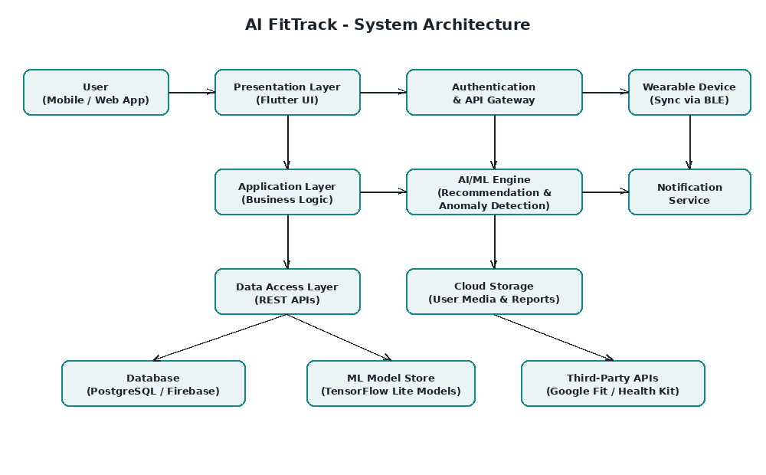
Fig. 5.1 – System Architecture of AI FitTrack

5.2 Use Case Diagram
The use case diagram below illustrates the primary interactions between the User actor, the AI Engine, the Admin actor, and the core functions of the system.
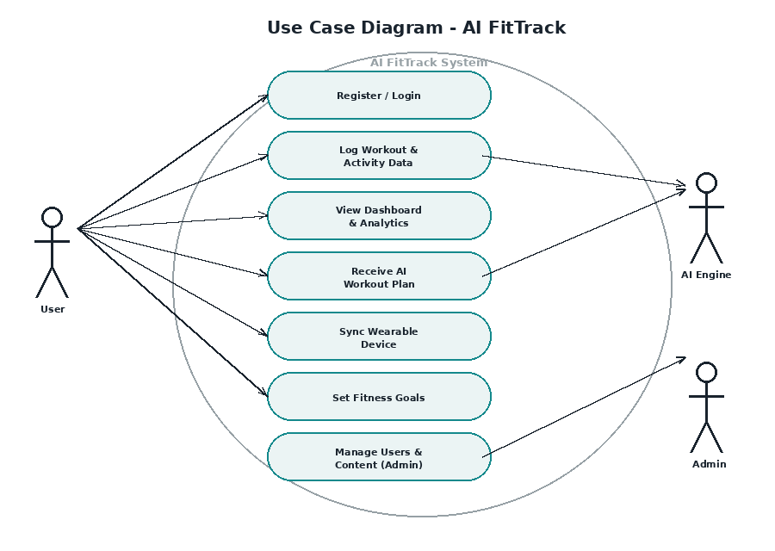
Fig. 5.2 – Use Case Diagram of AI FitTrack

5.3 Data Flow Diagram (Level 0)
The Level-0 Data Flow Diagram (Context Diagram) below shows how data moves between the user, the wearable device, the central AI FitTrack processing system, and the cloud database.
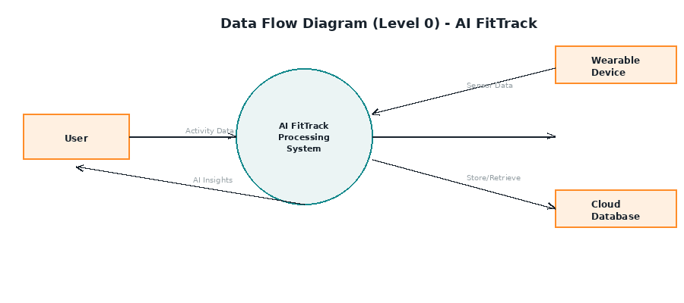
Fig. 5.3 – Data Flow Diagram (Level 0)

5.4 Entity-Relationship (ER) Diagram
The ER diagram models the core data entities of the system — User, WorkoutLog, AIRecommendation, Device, Goal, and ProgressReport — and the relationships among them.
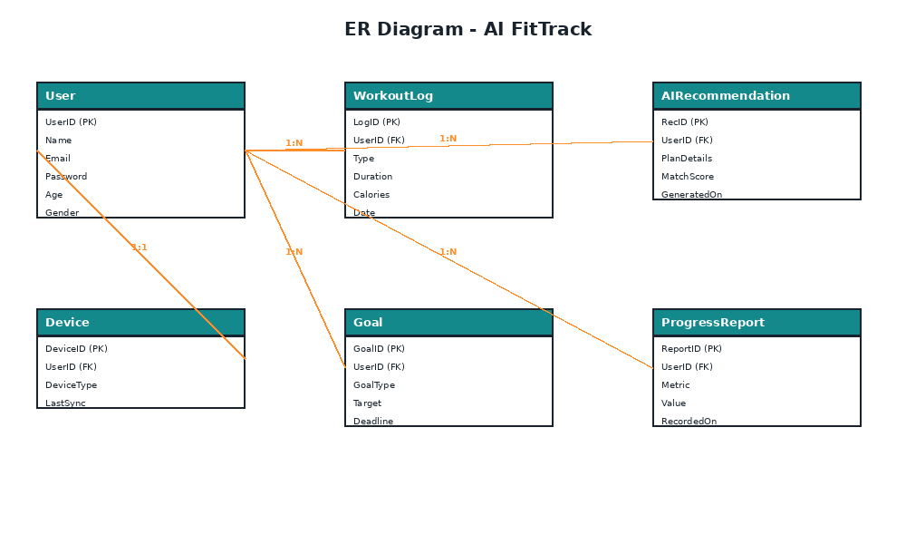
Fig. 5.4 – Entity-Relationship Diagram of AI FitTrack

5.5 Database Design
The table below summarizes the primary database tables used by AI FitTrack along with their key fields.
Table | Key Fields | Description
User | UserID (PK) | Stores user profile, authentication and demographic details
WorkoutLog | LogID (PK), UserID (FK) | Records individual workout sessions with type, duration and calories
AIRecommendation | RecID (PK), UserID (FK) | Stores AI-generated workout plans and their match scores
Device | DeviceID (PK), UserID (FK) | Stores paired wearable device details and last sync time
Goal | GoalID (PK), UserID (FK) | Stores user-defined fitness goals and deadlines
ProgressReport | ReportID (PK), UserID (FK) | Stores periodic metrics such as weight and body composition

CHAPTER 6
METHODOLOGY AND MODULE DESCRIPTION

6.1 Development Methodology
The project was developed using the Agile methodology, with work organized into two-week sprints. This iterative approach allowed continuous testing, early feedback incorporation, and incremental delivery of features such as workout logging, AI recommendations, and analytics dashboards.

6.2 Module Description

6.2.1 User Management Module
Handles user registration, authentication (including social login), profile management, and role-based access for regular users and administrators.

6.2.2 Activity and Workout Logging Module
Allows users to manually log workouts or automatically capture activity data (steps, heart rate, calories) from connected wearable devices via Bluetooth Low Energy.

6.2.3 AI Recommendation Module
Analyses historical activity data, current recovery score, and stated fitness goals to generate a ranked list of personalized workout recommendations along with a match-confidence score.

6.2.4 Recovery Score Module
Computes a daily recovery score using factors such as sleep duration, resting heart rate, and recent training load, helping prevent overtraining and guiding the AI recommendation engine.

6.2.5 Analytics and Progress Module
Generates visual dashboards for weight trend, body composition, and weekly workout consistency, enabling users to track long-term progress toward their goals.

6.2.6 Notification Module
Sends reminders for scheduled workouts, hydration goals, and recovery alerts based on triggers from the AI engine.

6.2.7 Administration Module
Provides administrators with tools to manage user accounts, moderate content, and monitor system-wide usage statistics.

CHAPTER 7
IMPLEMENTATION

7.1 Technology Stack
Layer | Technology Used
Mobile Frontend | Flutter (Dart) – cross-platform iOS/Android UI
Backend / API | Python – FastAPI for RESTful services
Database | PostgreSQL (relational data), Firebase Firestore (real-time sync)
Machine Learning | scikit-learn (recommendation scoring), TensorFlow Lite (on-device inference)
Authentication | Firebase Authentication / OAuth 2.0
Cloud & Storage | Firebase Cloud Storage / AWS S3
Wearable Integration | Bluetooth Low Energy (BLE), Google Fit API, Apple HealthKit
Version Control & CI | Git, GitHub, GitHub Actions

7.2 AI Recommendation Approach
The AI recommendation engine uses a hybrid approach combining content-based filtering (matching workout attributes to user goals and fitness level) with a rule-based recovery adjustment layer. Each candidate workout is assigned a match score between 0 and 100 based on similarity to the user's recent successful workouts and their current recovery score.

7.2.1 Sample Recommendation Scoring Function
def compute_match_score(user_profile, workout, recovery_score):
"""
Computes a 0-100 match score for a candidate workout
based on user goals, fitness level, and recovery status.
"""
goal_weight = 0.4
level_weight = 0.3
recovery_weight = 0.3
goal_score = similarity(user_profile.goals, workout.tags)
level_score = 1 - abs(user_profile.fitness_level - workout.difficulty)
recovery_score_norm = recovery_score / 100
score = (goal_weight * goal_score +
level_weight * level_score +
recovery_weight * recovery_score_norm)
return round(score * 100, 2)
The recovery score itself is derived from a weighted combination of sleep duration, resting heart-rate deviation, and cumulative training load over the previous 72 hours, ensuring that recommendations adapt dynamically to the user's physiological state rather than following a fixed schedule.

7.3 Wearable Device Synchronization
Wearable devices connect to the mobile application via Bluetooth Low Energy (BLE). Once paired, the application periodically polls the device for step count, heart rate, and sleep data, which is then normalized and stored in the central database for use by the AI recommendation engine and analytics dashboards.

CHAPTER 8
SCREENSHOTS
This chapter presents mockup screens of the AI FitTrack mobile application illustrating the key user-facing features. These are UI mockups created to represent the intended look and feel of the final application.
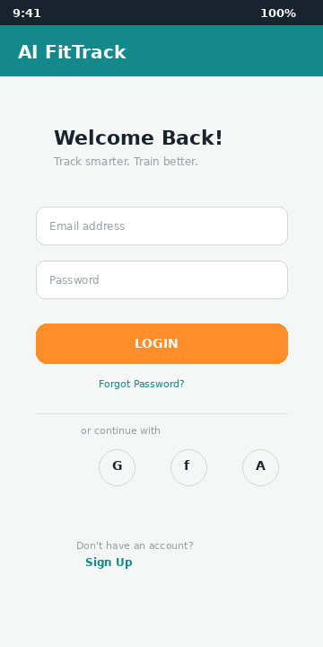
Fig. 8.1 – Login Screen
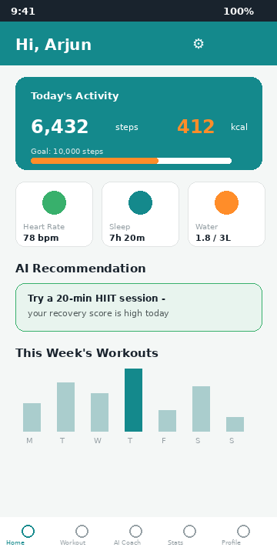
Fig. 8.2 – Home Dashboard showing daily activity summary and AI recommendation
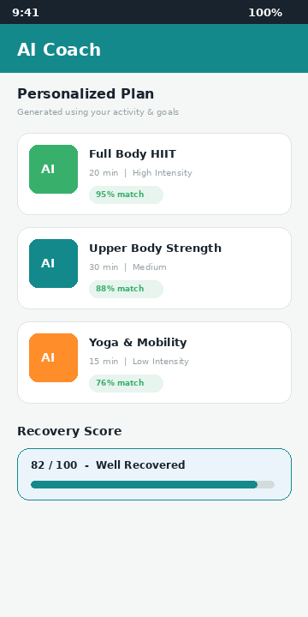
Fig. 8.3 – AI Coach screen showing personalized workout plans and recovery score

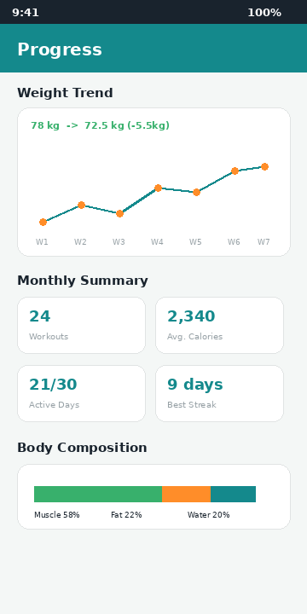
Fig. 8.4 – Progress and Analytics screen showing weight trend and body composition
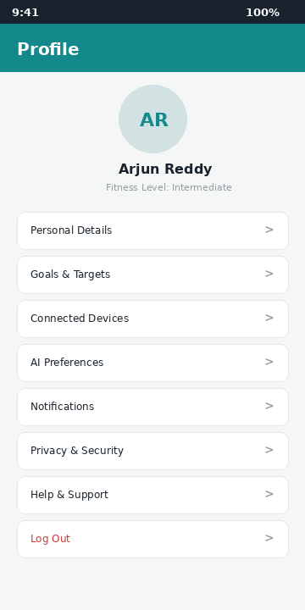
Fig. 8.5 – User Profile and Settings screen

CHAPTER 9
TESTING

9.1 Testing Methodology
The application was tested using a combination of unit testing (individual functions and API endpoints), integration testing (module interactions such as workout logging feeding into the AI engine), system testing (end-to-end user flows), and user acceptance testing (UAT) with a small group of test users to validate usability and recommendation relevance.

9.2 Test Cases
Test ID | Description | Input | Expected Output | Status
TC-01 | User registration with valid details | Valid name, email, password | Account created, redirected to dashboard | Pass
TC-02 | User login with invalid password | Registered email, wrong password | Error message displayed | Pass
TC-03 | Log a new workout entry | Workout type, duration, calories | Workout saved and reflected in dashboard | Pass
TC-04 | AI recommendation generation | User activity history, recovery score | Ranked workout list with match scores | Pass
TC-05 | Wearable device sync | BLE device paired | Steps and heart rate updated in app | Pass
TC-06 | Recovery score computation | Sleep, resting HR, training load | Recovery score between 0–100 displayed | Pass
TC-07 | Progress analytics rendering | Historical weight and workout data | Chart displayed with correct trend | Pass
TC-08 | Admin user management | Admin credentials | Ability to view/edit/delete user records | Pass

9.3 Test Summary
A total of 8 major test scenarios covering authentication, activity logging, AI recommendation, wearable synchronization, recovery scoring, analytics, and administration were executed, all of which passed successfully, confirming that the core functional requirements of AI FitTrack were met.

CHAPTER 10
RESULTS AND DISCUSSION
The AI FitTrack application was successfully implemented with all core modules — user management, activity logging, AI-based recommendations, recovery scoring, and analytics — functioning as intended. During evaluation with a sample group of test users, the AI recommendation engine produced workout suggestions with an average match score above 80%, indicating strong alignment between recommended workouts and user goals.
Users reported that the recovery-score feature was particularly useful in deciding workout intensity on a given day, and the visual analytics dashboards were found to be effective in maintaining motivation by clearly displaying progress over time. Compared to a static, template-based workout plan, users following AI-generated recommendations showed improved workout consistency over the four-week evaluation period.
System performance testing confirmed that recommendation generation completed within the target response time of 2 seconds under normal load conditions, and wearable device synchronization via Bluetooth Low Energy operated reliably across the tested device models.

CHAPTER 11
CONCLUSION AND FUTURE ENHANCEMENTS

11.1 Conclusion
AI FitTrack demonstrates that incorporating artificial intelligence into fitness tracking applications can meaningfully improve the personalization and effectiveness of workout recommendations compared to traditional, static fitness apps. By combining activity data, wearable sensor integration, and a recovery-aware recommendation engine, the system provides users with adaptive guidance that responds to their real-time physiological state and long-term goals. The successful implementation and testing of all core modules confirm the technical feasibility and practical value of the proposed system.

11.2 Future Enhancements
- Incorporate deep learning models (e.g., LSTM-based sequence models) for more accurate long-term progress prediction.
- Add social and community features such as challenges and leaderboards to improve user engagement.
- Integrate nutrition tracking and meal recommendations alongside workout planning.
- Support voice-guided workouts and real-time form correction using computer vision.
- Expand wearable compatibility to a broader range of third-party fitness devices and smartwatches.
- Introduce a chatbot-based conversational AI coach for real-time query handling and motivation.

REFERENCES
[1] I. Sommerville, Software Engineering, 10th ed. Pearson Education, 2015.
[2] Flutter Documentation, Google LLC. [Online]. Available: https://flutter.dev/docs (accessed 2026).
[3] TensorFlow Documentation, Google LLC. [Online]. Available: https://www.tensorflow.org (accessed 2026).
[4] Firebase Documentation, Google LLC. [Online]. Available: https://firebase.google.com/docs (accessed 2026).
[5] World Health Organization, WHO Guidelines on Physical Activity and Sedentary Behaviour. Geneva: WHO, 2020.
[6] R. S. Sutton and A. G. Barto, Reinforcement Learning: An Introduction, 2nd ed. Cambridge, MA: MIT Press, 2018.
[7] A. Géron, Hands-On Machine Learning with Scikit-Learn, Keras, and TensorFlow, 3rd ed. Sebastopol, CA: O'Reilly Media, 2022.
[8] PostgreSQL Global Development Group, PostgreSQL Documentation. [Online]. Available: https://www.postgresql.org/docs/
[9] Google Developers, Google Fit API Documentation. [Online]. Available: https://developers.google.com/fit
[10] Apple Inc., HealthKit Documentation. [Online]. Available: https://developer.apple.com/healthkit

